Project Planning Phase
Sprint Delivery Plan

Date | 18 October 2022
Team ID | PNT2022TMID14584
Project Name | Customer Care Registry
Maximum Marks | 8 Marks

Velocity:
Imagine we have a 10-day sprint duration, and the velocity of the team is 20 (points per sprint). Let’s calculate the team’s average velocity (AV) per iteration unit (story points per day)

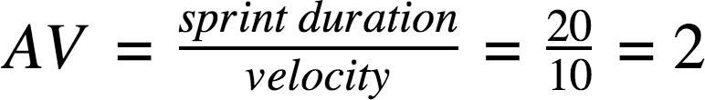

Product Backlog, Sprint Schedule, and Estimation (4 Marks)

Use the below template to create product backlog and sprint schedule

Sprint | Functional  Requirement (Epic) | User Story  Number | User Story / Task | Story Points | Priority | Team Members
Sprint-1 | User Panel | USN-1 | The user will login into the website and go through the  services available on the web page | 20 | High | Ilamvazhuthi J  Aswin venkat
Sprint-2 | Admin panel | USN-2 | The role of the admin is to check out the database about the availability and have a track of all the things that the users are going to service | 20 | High | Priyadharshan  Abhay Deep
Sprint-3 | Chat Bot | USN-3 | The user can directly talk to Chat bot regarding the services. Get the recommendations based on information provided by the user. | 20 | High | Ilamvazhuthi J  Priyadharshan
Sprint-4 | final delivery | USN-4 | Container of applications using docker kubernetes and deployment the application. Create the documentation and final submit the application | 20 | High | Ilamvazhuthi J  Aswin Venkat R  Abhay Deep

Project Tracker, Velocity & Burndown Chart: (4 Marks)

Sprint | Total Story Points | Duration | Sprint Start Date | Sprint End Date (Planned) | Story Points Completed (as on Planned End Date) | Sprint Release Date (Actual)
Sprint-1 | 20 | 6 Days | 24 Oct 2022 | 29 Oct 2022 |  | 29 Oct 2022
Sprint-2 | 20 | 6 Days | 31 Oct 2022 | 05 Nov 2022 |  | 05 Nov 2022
Sprint-3 | 20 | 6 Days | 07 Nov 2022 | 12 Nov 2022 |  | 12 Nov 2022
Sprint-4 | 20 | 6 Days | 14 Nov 2022 | 19 Nov 2022 |  | 19 Nov 2022

BURNDOWN CHART
